ZircoNeo Debug Command
2019/8/26

Contents
ZircoNeo Debug Command 0
Contents 1
1. Command syntax description 2
2. ZIRCO HOST BOARD UART Commands List 3
3 Module Debug 4
3.1 TWI 4
3.2 I2C 5
4 Host Board Debug 5
4.1 AIN 5
4.2 KB Coefficient 6
4.3 AOUT 6
4.4 DIN 7
4.5 DOUT 7
4.6 EEPROM 8
4.7 FLASH 9
4.8 IFLASH 9
4.9 Erase flash 10
4.10 FPGA 11
5 File DOWNLOAD 11
5.1 DL 11
6 Misc 12
6.1 Version 12
6.2 Serial Number 12
6.3 Password 12

Command syntax description
The commands can be transferred to Ethernet/USB using a standard terminal program. All host commands start with the "*" character. If several parameters are required, the command is followed by the parameters separated with a space character. Then the termination sequence follows at the end of the parameters.

This draft command set is designed for easy reading, meaning that all commands are string acronym.

- The commands have the following syntax:
*COMMAND [ parameters]
- The star "*" is the designator showing the start of a command.
- If there is more than one parameter, they are separated by a space character.

- The command return has the following format:
$0000;<command>return0 return1…
- If MCU returns no data, no “return0 return1…” in the above format.
e.g.

Command | Command Return
*QSFPW 0 2 1 2 | $0000;< QSFPW 0 2 1 2 >

- If several values are required to return, they are separated by a space character.
The values can be in DECIMAL, HEXADECIMAL format.
e.g.
Command | Command Return
*ed_count -g 0 | $0000;< *ed_count >0000 0000 0000

- If there is no error during the command execution, the preamble string is “$” followed by “0000”.
The preamble string represents errors which occurred during command execution. The value following “$” is bit-wise coded. The value bits have the following meanings:
Bit | Hex-Value | Description
- | 0x00 | No errors
0 | 0x01 | Invalid command
1 | 0x02 | Command checksum error
2 | 0x04 | Missing parameter
3 | 0x08 | Time out
4-5 |  | Reserved for future use
6 | 0x40 | Parameter out of range
e.g.
Command | Command Return
*i2c | $0004;

- The termination sequence follows at the end of the command return string.

ZIRCO HOST BOARD UART Commands List
command list

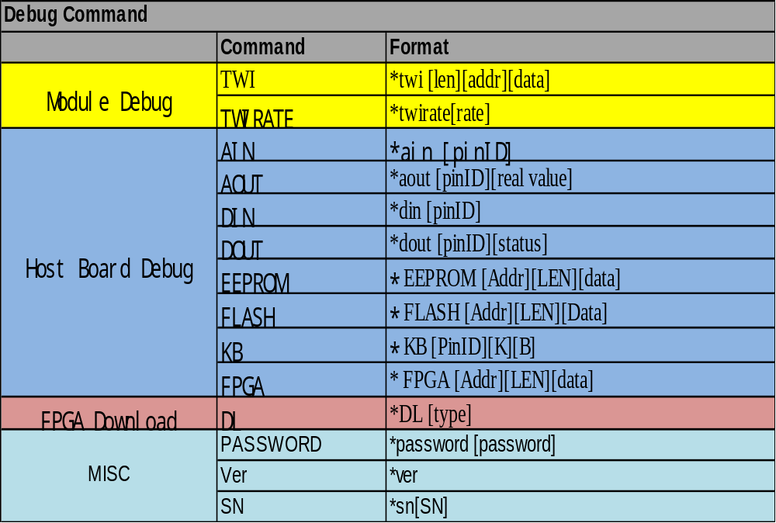

Module Debug

TWI
Command | *TWI
Function | cmdTWI ()
Purpose | Write/Read data into/from module
Format | *twi [len][addr][data]
Parameters | - Read current address (read data from the current address)  *twi [len] (len: 1~ 256)  - Random read operation  *twi [len][addr] ( len: 1~256, address: 0~255)  - Write operation  *twi [len][addr][data]  (len: 1~256, addr: 0~255, data: each data is byte unit, the data number must equal len)  If the len is bigger than 1, it means sequence read/write operation
Returns | $0000;<*twi>data1 data2 ….
Example | *twi 1 (read current address data)  $0000;<*twi 1>23  *twi 2 (read 2 bytes from current address)  $0000;<twi 2> 00 21  *twi 1 126 ( read address 126 data)  $0000;<twi 1 126> 21  *twi 2 126 (read 2 bytes from address 126)  $0000;<twi 2 126>21 1  *twi 1 126 25 ( write 25 into address 126)  $0000;<twi 2 126 25>  *twi 2 126 0x30 1 (write 0x30 and 1 into address 126 and 127)  $0000;<twi 2 126 0x30 1>

I2C
Command | TWIRATE
Function | cmdTwirate ()
Purpose | Change host board twi rate
Format | *twirate [rate]
Parameters | rate: rate of twi (uint is Kpbs)  100 – 100K, 400—400K. 1000—1M  Without rate, the command is ro read twi rate
Returns | $0000
Example | * twirate 1000 (Set twi rate to 1M)  $0000;<twirate 1000>

Host Board Debug

AIN
Command | AIN
Function | cmdAIN()
Purpose | Read analog date
Format | *ain [pinID]
Parameters | pinID: list below
Returns | $0000;<pin name>[adc] [real value]
Example | *ain 1  $000;< P3V3_OSFP>3.304

PinID list
Pin Name | Pin ID
P3V3_OSFP_CURR_CHECK | 100
P3V3_OSFP | 101
P3V3_OSFP_CON | 102
P1V0_FPGA | 103
P1V8_FPGA_OSFP | 104
MODULE_CASE_TEMP1 | 105
P3V3_FPGA | 106
P2V5_REF | 107
Temperature 1 | 108
Temperature 2 | 109
P5V_USB_DEBUG | 110
Module_Power | 111

KB Coefficient
Command | KB
Function | cmdKB()
Purpose | Set/get k,b calibration coefficient.
Format | * KB [PinID][K][B]
Parameters | [PinID] , refer to ain  [k] , slope, floating  [b], intercept, floating  Without k and b, means reading
Returns | $0000;<*kb>0.9929 1.00
Example | *kb 101 1.002 0.123  $000  Set 3.3V calibration coefficient

AOUT
Command | AOUT
Function | cmdAOUT()
Purpose | Set analog real value
Format | *aout [pinID][real value]
Parameters | pinID: list below  [real value]: floating number  Without real value is to read setting value
Returns | $0000;<pin name> or $0000;<pin name> [real value]
Example | *ain 1

PinID list
Pin Name | PinID
P3V3_OSFP | 101

DIN
Command | DIN
Function | cmdDIN()
Purpose | Read GPIO
Format | *din [pinID]
Parameters | pinID: list below
Returns | $0000;<pin name> [pin status]
Example | *pin 22

PinID list
Pin Name | PinID
H_INTN | 1
H_PRSN | 2
MOD_RSTN | 3
MOD_PLWN | 4
SW_TEST_RSVD_4 | 5
TEMP_ALERT_1 | 6
TEMP_ALERT_2 | 7

DOUT
Command | DOUT
Function | cmdDOUT()
Purpose | Set GPIO status
Format | *dout [pinID][status]
Parameters | pinID: list below  [status] 0/1
Returns | $0000;
Example | *pin 22 1

PinID list
Pin Name | Pin ID
MCU_MOD_RSTN | 20
MCU_MOD_LPWN | 21
MCU_BUFFER_H_RSTN | 22
MCU_BUFFER_H_LPWN | 23
H_LPWN_OE_N | 24
H_RSTN_OE_N | 25
P1V0_FPGA_EN | 26
P1V8_FPGA_EN | 27
P3V3_FPGA_EN | 28
P3V3_OSFP_IN_EN | 28
P3V3_LDO_EN | 30
LED_HIGH_POWER_ON | 31
LED_MOD_READY | 32
LED_MOD_FAULT | 33
LED_RX_LOS | 3
LED_MOD_ABS | 35
LED_TX_DIS | 36
LED_MOD_LOPWR | 37
LED_RSVD_1 | 38
LED_GLOBAL_ALARM_N | 39
LED_MOD_RST_N | 40
MCU_PHY_RSTN | 41
MCU_FPGA_RSTN | 42
MCU_FPGA_PROGRAM_B | 43
MCU_FPGA_INIT_B | 44
USB_DIS_N | 45
MCU_MEM_SPI_OE_N | 46
MCU_ADC_SPI_OE_N | 47
MCU_MEM_BUF_SPI_CS | 48
MCU_ADC_BUF_SPI_CS | 49
MCU_FPGA_COMM_SPI_CS_BUFFER | 50
MCU_FPGA_CFG_SPI_CS_BUFFER | 51

EEPROM
Command | EEPROM
Function | cmdEEPROM()
Purpose | Write/Read EEPROM.
Format | * EEPROM [Addr][LEN][data]
Parameters | RegAddr: FPGA register address  [LEN] the length of data  Data: data (unit is uint8)  Without data, the command is read
Returns | $0000;<*EEPROM>data1, data2,…
Example | *EERPOM 0x11 5 0 1 2 3 4  $0000  Write “0, 1, 2, 3,4 into EEPROM from address 0x11.  *EEPROM 0x11 5  &0000;<*eeprom>0 1 2 3 4  Read 5 data from eeprom from address 0x11

FLASH
Command | FLASH
Function | cmdFLASH()
Purpose | Write/Read external flash data
Format | * FLASH –r/p/e/b [Addr][LEN][Data]
Parameters | Addr: address  -r read  -p program  -e 4K page erase  -b Sector erase ( Addr = 0~63)  [LEN] the length of data  [data]: unit is unit8
Returns | $0000;<*flash> data1 data2 …
Example | *FLASH -p 0x0 5 0 1 2 3 4  $0000;<*flash –p>  Write 5 data 0,1,2,3 and into address 0 of flash  *FLASH -r 0x0 5  $0000;<*flash -r>0 1 2 3 4  read 5 data from address 0 of flash

IFLASH
Command | IFLASH
Function | cmdFLASH()
Purpose | Write/Read MCU flash data
Format | * FLASH –r/b/e [Addr][LEN][Data]
Parameters | Addr: address  -r read  -p program  -b Sector erase ( Addr = 0~7)  [LEN] the length of data  [data]: unit is unit8
Returns | $0000;<*iflash> data1 data2 …
Example | *iFLASH -p 0x0 5 0 1 2 3 4  $0000;< *iFLASH -p >  Write 5 data 0,1,2,3 and into address 0 of flash  *iFLASH -r 0x0 5  $0000;<*iflash -r>0 1 2 3 4  read 5 data from address 0 of flash

Erase flash
This command need password available.
Command | Erase
Function | cmdErase()
Purpose | Erase all flash
Format | * erase [type][Addr]
Parameters | [type]: 1—MCU flash  [Addr]: Sector address 0~7  [type]: 2 – page erase of external flash  [Addr]: page erase begin address ( 4K boundary)  [type]: 3—Sector erase of external flash  [Addr]: Sector address 0~63
Returns | $0000;<erase >
Example | *ERASE 16 (erase MCU flash sector 6)  $0000;<*flash 1 6>  *ERASE 2 0x2000 (erase 4K from 0x2000 of external flash )  $0000;<*flash 2 0x2000>  *ERASE 3 6 (erase sector 6 of external flash)  $0000;<*flash 3 6>

FPGA
Command | FPGA
Function | cmdFPGA()
Purpose | Write/Read FPGA Registers.
Format | * FPGA [Addr][LEN][data]
Parameters | Addr: FPGA register address  [LEN] the length of data  Data: data (unit is uint8)
Returns | $0000;<*fpga> data1 data2 …
Example | *FPGA 0x11 5 0 1 2 3 4  $0000  Write “0, 1, 2, 3,4 into FPGA from address 0x11.  *FPGA 0x11 5  &0000;<*FPGA>0 1 2 3 4  Read 5 data from address 0x11 of FPGA
Note: when write /read data from FPGA, need to check FPGA available first.

File DOWNLOAD

5.1 DL
Command | DL
Function | cmdDL()
Purpose | Block data write/read
Format | *DL [type][Command]
Parameters | This command is special.  [Type] 1—HOST FPGA  2—HOST FW  [Command] 1--- DL Start  2—DL complete  3—Verify  4—Switch  5—Commit  1 and 2 must be executed together.  After 1, download binary file can be transmitted via another Ethernet port.
Returns | $0000
Example

Misc

Version
Command | *Ver
Function | cmdVer()
Purpose | Get HOST FW and FPGA version
Format | *VER
Return format:
FW verison +FW iamge No+FPGA versoin
Returns | $0000
Example

Serial Number
Command | SN
Function | cmdSN()
Purpose | Set/get host board SN
Format | * SN [serial number]
Parameters | [Serial number] , it’s a string, maximum is 16 letters  [Without k and b, means reading
Returns | $0000;
Example | *sn SN1234567  $0000

Password
Command | Password
Function | cmdPassword()
Purpose | Write passwrod
Format | *password [password]
Parameters | [password] , it’s a string
Returns | $0000;
Example | *password NWH2019  $0000
The initial password is “NWH2019”

